**Leela Morris**

<https://github.com/lnm29/CS1632_Deliverable3>

**CS 1632 – DELIVERABLE 3: Unit Testing**

SUMMARY:

First going into the project, my biggest concern was writing tests that wouldn’t necessarily fail due to the way I could possibly write them. During class, we talked about how to write Junit tests for web applications and what tests were not applicable to our case. Another concern that came across my mind was not getting any of the test to work correctly. During the exercise that was given in class that corresponds to this Deliverable, my group and I couldn’t get the tests that we wrote to work properly. We spoke to you about it and you also had trouble finding the problem.

I have less than 20 tests because I tried to make sure all of the current tests I had were accurate enough. My tests seem to be simple and a few are glitchy, but I tried my best to write proper web development tests that convey our website is working as efficiently as it should. I have two tests that are commented out because I could get them to work properly. What the two methods are supposed to be doing is going to the hello link at the top of the page, clicking it, and then typing the desired trailing values. I found one of my defects in the trailing values, but my test did not accurately portray what should happen when that certain value is. The other method shows a trailing value that work (the trailing value appears in the message on the screen). I have a few failures in my testing that can be seen in the screen shots below.

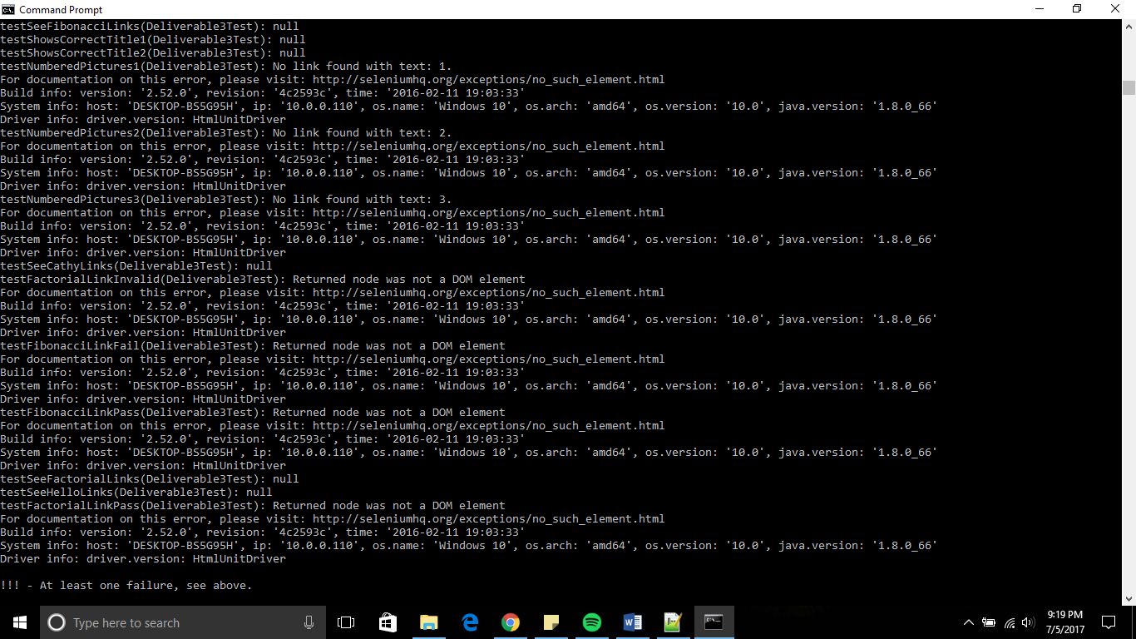

DEFECTS:

1. TRAILING VALUE DEFECT:

SUMMARY: When the trailing value, ‘]’ is added to the url when accessing the /hello page, an exception is thrown.

DESCRIPTION: Per requirement 7, if a trailing value is provided in the URL when accessing the /hello page, then the message shall display hello from the trailing value. When the value, ‘]’, is added to /hello (/hello/]), the webpage displays an application error.

REPORDUCTION STEPS:

1. Open a web browser of your choice (Google Chrome, FireFox, etc.) and wait for the homepage to load.
2. Go to the search bar and click. A blinking cursor should appear.
3. Type the url <https://cs1632ex.herokyapp.com/> and press the Enter key on your keyboard.
4. When the page loads, click the fourth link from the left that says ‘Hello’ and wait for the webpage to load.
5. Once that is loaded, a message says “Hello CS1632, from Prof. Laboon!”. Go to the search bar and add a respective message after ‘hello’ and that message shall be revealed when the page reloads.

EXPECTED BEHAVIOR: The message should change according to any trailing value given by the user.

OBSERVED BEHAVIOR: The specific trailing value ‘]’ causes the website to throw an error.

SEVERITY: This could be considered critical due to the fact that it throws an error and the entire webpage is directed elsewhere.

IMPACT: This leaves the user unable to display that webpage (can lead to confusion, usability issues , etc.).

1. HOMEPAGE DEFECT:

SUMMARY: When the homepage of the website loads, an extra title is among the specified titles.

DESCRIPTION: Per requirement 1, the homepage shall display the text “Welcome, friend, to a land of pure calculation” as well as “Used for CS1632 Software Quality Assurance, taught by Bill Laboon”, but an extra title appears underneath ‘THE WORLD IS YOUR OYSTER’.

REPRODUCTION STEPS:

1. Open a web browser of your choice (Google Chrome, FireFox, etc.) and wait for the homepage to load.
2. Go to the search bar and click. A blinking cursor should appear.
3. Type the url <https://cs1632ex.herokyapp.com/> and press the Enter key on your keyboard.
4. The website is automatically sent to the homepage and there is where the titles “Welcome, friend, to a land of pure calculation” as well as “Used for CS1632 Software Quality Assurance, taught by Bill Laboon” appear.

EXPECTED BEHAVIOR: The two titles stated in requirement 1, “Welcome, friend, to a land of pure calculation” and “Used for CS1632 Software Quality Assurance, taught by Bill Laboon” alone appear on the home page.

OBSERVED BEHAVIOR: An extra title, “THE WORLD IS YOUR OYSTER”, that was not specified appears underneath the other two titles.

SEVERITY: This defect would be considered minor. The webpage is still viewable and works per the requirements.

IMPACT: This would be low impact. The user may just be confused but the respective titles still appear.

1. FIBONACCI DEFECT:

SUMMARY: When one of the edge cases (100) is typed into the Fibonacci text box and calculated it gives the answer that should be given to anything over 100 or less than 1.

DESCRIPTION: Per requirement 4, the user can enter a positive integer from 1 to 100 on the Fibonacci page and upon pressing submit, shall show to the user the Fibonacci of the value. If the integer is less than 1 and larger than 100, they will be informed that the value is 1. When ‘100’ is typed into the Fibonacci text box and calculated upon submitting.

REPRODUCTION STEPS:

1. Open a web browser of your choice (Google Chrome, FireFox, etc.) and wait for the homepage to load.
2. Go to the search bar and click. A blinking cursor should appear.
3. Type the url <https://cs1632ex.herokyapp.com/> and press the Enter key on your keyboard.
4. When the page loads, click the third link from the left that says ‘Fibonacci’ and wait for the webpage to load.
5. The page reveals the title “Enter number to calculate Fibonacci of:” and a text box. Enter the integer ‘100’.

EXPECTED BEHAVIOR: The answer to the Fibonacci of 100 should be given to us upon clicking submit.

OBSERVED BEHAVIOR: The answer given for the Fibonacci of 100 displayed is 1 which is the answer that is given when the given integer is less than 1 or greater than 100.

SEVERITY: This could be considered critical because it goes against one of the requirements specifically.

IMPACT: The user will not get the correct response which could lead to other errors.